FUTSAL BOOKING SYSTEM
FOR
STAR FUTSAL

BY
Bipin Masal
7-2-551-194-2020
National College of Computer Studies

A Summer Project Report Submitted to
Faculty of Management, Tribhuvan University
in partial fulfillment of the requirements for degree of
Bachelor of Information Management

Paknajol, Kathmandu
June 2024

STUDENT DECLARATION
This is to certify that I have completed the summer project entitled “Futsal Booking System” under the guidance of “Mr. Teksan Gharti Magar” in partial fulfillment of the requirements for the degree of Bachelor of Information Management at Faculty of Management, Tribhuvan University. This is my original work and I have not submitted it earlier elsewhere.

Date: June 2024
Signature: ……………...
Bipin Masal

CERTIFICATE FROM THE SUPERVISOR
This is to certify that summer project entitled “Futsal Bookings System” is an academic work done by “Bipin Masal” submitted in the partial fulfillment of the requirement for the degree of Bachelor of Information at Faculty of Management, Tribhuvan University under my guidance and supervision. To the best of my knowledge, the information presented by him in the summer project report has not been submitted earlier.

Signature of the Supervisor
Mr. Teksan Gharti Magar
Supervisor
June 2024

ACKNOWLEDGEMENTS
This Summer Project entitled "Futsal Booking System for Star Futsal" under the guidance of "Mr. Teksan Gharti Magar" is prepared in partial fulfillment of the requirements for the degree of Bachelor of Information Management, Faculty of Management, Tribhuvan University. First, I would like to thank the National College of Computer Studies for giving us an opportunity to conduct this summer project. I would like to express my sincere gratitude to my supervisor for providing valuable guidance, comments, and suggestions throughout the course of this summer project.
Also, I would like to thank the organization I worked this project on, i.e. Star Futsal, for giving me an opportunity to conduct study and make this report. I would like to thank my classmates who have been giving me continuous support and advice to complete this project. Finally, I would like to thank all those who have been directly or indirectly connected to this project.

Bipin Masal

EXECUTIVE SUMMARY
The Futsal Booking system is a web-based software solution and this report is based on the futsal management system itself as per the requirement of TU. The system is made for "Star Futsal", a Futsal located at Samakhusi, Kathmandu, Nepal. This system will help the organization to provide a friendly user interface for numerous futsal bookings.
Chapter one outlines the objectives and methodology adopted for the report, emphasizing the use of interviews with the owner and the Prototype Model used for structured progress. The project framework, data collection methods, tools used, and project report analysis techniques are also discussed.
Chapter two delves into the tasks and activities performed during the project. This includes the analysis of tasks, activities, problems, and issues faced by “Star Futsal”, as well as the exploration of possible solutions. The feasibility study is done as technical, economic, and operational aspects of implementing a booking system. Requirement specification is specified into the functional and non-functional requirement which shows the functionality of the organization. The system is analyzed and shown in different diagrams such as use-case diagram, Entity-Relationship diagram, activity diagram and sequence diagram. The chapter concludes with system testing, validation testing and findings from the project development process.
In Chapter three, discussions focus on the implications and outcomes of developing the futsal booking system for “Star Futsal”. The project addresses existing challenges in booking and distribution processes and offers solutions for manual system for booking the futsal court. The conclusion reflects the successful completion of the project within the stipulated timeframe and its contribution to the organization's digital transformation and which helps me lot to enhance, showcase by skill.

TABLE OF CONTENTS
Title Page
Student Declaration i
Certificate from the Supervisor ii
Acknowledgements iii
Executive Summary iv
Table of Contents v
List of Figures viii
List of Tables ix
Abbreviations x
CHAPTER I INTRODUCTION 1
1.1 Background 1
1.2 Introduction of the organization 1
1.3 Current Situation 1
1.4 Problem Statement 1
1.5 Objective 1
1.6 Methodology 2
1.6.1 Project Framework 2
1.6.2 Data and Information 3
1.6.3 Tools Used 3
1.6.4 Techniques of the project report analysis 3
CHAPTER II TASK AND ACTIVITIES PERFORMED 4
2.1 Problem Analysis 4
2.2 Analysis of the possible solutions 4
2.3 Feasibility study 4
2.3.1 Technical Feasibility 4
2.3.2 Economic Feasibility 4
2.3.3 Operational Feasibility 4
2.4 Requirement Analysis 4
2.4.1 Functional Requirement 5
2.4.2 Non-Functional Requirement 5
2.5 System Design and Development 5
2.5.1 Use-Case Diagram 5
2.5.2 ER-Diagram 8
2.5.3 Activity Diagram 9
2.5.4 Sequence Diagram 11
2.6 System Testing 11
2.6.1 Unit Testing 12
2.6.2 Test case 12
2.6.3 Validation Testing 13
2.7 Findings 13
CHAPTER III DISCUSSION AND CONCLUSION 14
3.1 Discussion 14
3.2. Conclusion 14
REFERENCES
APPENDICES a

LIST OF FIGURES
Figure 1.1: Prototype Model 2
Figure 2.1: Use case Diagram 6
Figure 2.2: ER-Diagram 8
Figure 2.3: Client-side Activity Diagram 9
Figure 2.4: Admin-side Activity Diagram 10
Figure 2.5: Sequence Diagram 11

LIST OF TABLES
Table 2.1: Description of the Use-case Diagram 7
Table 2.2: Test-Case 12

ABBREVIATIONS
BIM Bachelor of Information Management
CSS Cascading Style Sheet
ERD Entity Relationship Diagram
GUI Graphical User Interface
MySQL My Structured Query Language
PHP Hypertext Preprocessor
TU Tribhuvan University
UML Unified Modelling Language
XAMPP Cross-Platform(X), Apache(A), MySQL(M), PHP(P) and Perl(P)

CHAPTER I INTRODUCTION

1.1 Background
This report is on the Summer Project entitled “Futsal Booking System” for an organization named Star Futsal. It is a web application which offers a convenient and user-friendly interface for both Customer and owner. In the past, Futsal’s used to rely on manual systems, such as pen and paper, to keep track of their bookings. This system aims to keep data of the futsal booking more accurate than that of storing data manually. Once the registration and bookings are completed, it automatically saves the data into the database. This eliminates the need for phone calls or in-person inquiries, saving time and effort. This also helps in reducing the paperwork and mismanagement of bookings.

1.2 Introduction of the organization
Star Futsal is located at Samakhusi, Kathmandu. Star Futsal was established with the objective of serving a good quality environment for playing. Futsal offers various football pitch sets.i.e. is A and B grade ground with a happy dressing room. Futsal is known for cheap ground, friendly faces, and galactic price of options for all services. The futsal opens at early morning 6 AM and closes at 10 PM. The main motive of the organization is to provide a quality playing environment and services to their customers.

1.3 Current Situation
At present the reservation is conducted through direct communication with the futsal venue. Players interested in booking a futsal court typically contact the venue by phone, email, or in person. They inquire about the availability of the court for their desired date and time, providing details such as the number of players and duration of play. Once the availability is confirmed, players provide their personal information and may be required to make a payment, either in person or through specified payment methods. The venue then provides confirmation of the booking, along with a receipt if applicable.

1.4 Problem Statement
- Staff in the organization used to book futsal court manually.
- Auditing the bill history manually.
- Double booking of the pitch at the same time.

1.5 Objective
- To provide an online system for booking futsal.
- To provide a computerized system for managing bill history.
- To minimize the level of double booking.

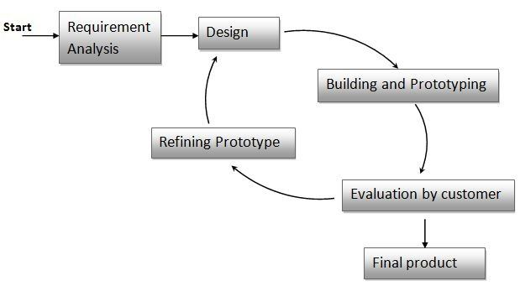
1.6 Methodology
Figure 1.1: Prototype Model (geeksforgeeks, 2024)
The selection of the prototype model for this project is based on its structural approach, providing clear phases from requirement to final product. It is used to build a rough sketch of the Futsal Booking System before diving into the details. Talked to the people who will use the system and figured out what they want it to do. Then, create a simple version of the system with just the main features. Now show it to the users and ask them to try it out, like trying on a new pair of shoes to see if they fit comfortably. Based on their feedback, adjust, and improve until everyone is satisfied. Once have a clear picture of how the system should work, then write down all the specific things it needs to do, like making sure users can easily book futsal courts online and see which slots are available. Then, start building the actual system and test it extensively to make sure it runs smoothly, just like test-driving a car before hitting the road. As people start using the system, continue to listen to their feedback and make further refinements to make sure it meets their needs perfectly, like adding extra features or fixing any bugs that pop up along the way. (geeksforgeeks, 2024)

1.6.1 Project Framework
The overall project is divided into three segments. They are:
- Introduction
- Analysis
- Discussion and Collection

- Introduction
In this segment I have tried to give a brief introduction to the organization and the current situation of the organization. This segment also highlights the problems the organization is facing and the software which can be used to solve those problems. Not only that the objective of the report, but issue also related with the report, data and tools and techniques used to create report are also presented in this segment.
- Analysis
In this segment analysis the software is done using various tools. I have included the total working mechanism of the software and represented it using various diagrams like activity diagram, use-case diagram, sequence diagram, test-case.
- Discussion and Conclusion
This segment is used to discuss how the company is currently managing its customers service, the problems it is facing and how software can help it to increase its efficiency and the effectiveness of performance of the organization.

1.6.2 Data and Information
The data and information for this report were collected very carefully using two methods. They are:
- Primary data collection method
- Secondary data collection Method

- Primary data collection
The primary data are those data which are collected fresh and for the first time. This data is obtained by a study specifically designed to fulfill the data needs of the problems at hand. Such data are original in character. The primary data were collected from interviews and observations.
- Secondary data collection method
The secondary data are those which have already been collected by someone else and which have already been passed through the statistical processes. Thus, such data is not originally collected but rather obtained from published or unpublished sources. The secondary data were collected using the internet and books. Which helped to know which type of software will be suitable for the organization.

1.6.3 Tools Used
For the software development, different tools and languages are used:
- Backend: PHP
- Frontend: HTML, CSS, JavaScript, Bootstrap
- Database: MySQL
- Database Server Implementation: XAMPP
- Editor: Visual Studio Code
- Diagram: Draw.io

1.6.4 Techniques of the project report analysis
As for the data collection, the different types of tools that can be used are:
- Interview
A direct personal interview method was used to collect the information from the employees by personally visiting and meeting the people from whom data must be collected.
- Internet
For the development of a suitable system to solve the existing problem of the organization, various related information has been collected from different sites on the internet.
- Observation
The activities on the organization's premises were observed and analyzed accordingly to study the working mechanism and to study the problem.

CHAPTER II TASK AND ACTIVITIES PERFORMED

2.1 Problem Analysis
“Star Futsal” used manual booking, which is time-consuming and inconvenient, requiring players to contact the futsal venue directly and inquire about court availability. Lack of real-time information on court availability can lead to double bookings or players arriving at the venue only to find that the court is already occupied.

2.2 Analysis of the possible solutions
Possible solutions to the known problem of the organizations can be as follows:
- Creating an interface for clients to book the futsal.
- Creating a digitized system for staff to handle/manage the bookings.

2.3 Feasibility study
The purpose of this feasibility study is to assess the viability and potential benefits of implementing a futsal reservation system. The system aims to simplify the process of booking futsal courts online for customers, while providing efficient management capabilities for the futsal facility. This study will evaluate the technical, economic, and operational aspects of the system to determine its feasibility. (StackoOverflow, 2024)

2.3.1 Technical Feasibility
The system demonstrates strong technical feasibility, meeting all necessary requirements. The website is cross-platform compatible, making it portable. Clients can access it from any location with an internet connection. All the system requirements are supported by the system including Linux, Windows, UNIX, and Mac. As a result, there will be no problems during processing on any devices.

2.3.2 Economic Feasibility
The system is economically feasible as the development costs are minimal. The resources used for designing this website are easily accessible and completely free via the internet. It indicates whether the system is within the available budget that is feasible to implement.

2.3.3 Operational Feasibility
Operational Feasibility evaluates how effectively a proposed system meets the needs identified in the requirement analysis phase of the system development, resolves any issue, and capitalizes on opportunities outlined during scope definition. The system’s intuitive, GUI-based interface ensures that even users without technical expertise can easily operate it.

2.4 Requirement Analysis
Requirement analysis is the process of identifying, documenting, and understanding the needs and expectations of stakeholders for a particular project. It involves gathering information, analyzing, and prioritizing requirements to define the scope and deliverables of the project accurately. The goal of requirement analysis is to ensure that the final solution meets the desired objectives, satisfies user needs, and aligns with the overall business goals. This includes both functional and non-functional requirements.

2.4.1 Functional Requirement
Functional requirements are product features or functions that developers must implement to enable users to accomplish their tasks. So, it's important to make them clear both for the development team and the stakeholders.
Some Functional Requirements of System are as follows:
- User Registration and Authentication: Users should be able to register for an account and log in securely.
- Facility Search and Booking: Users should be able to search for futsal facilities based on location, availability, and other criteria. Booking slots should be displayed, and users should be able to reserve slots for specific times.
- Integration with Maps: Integration with mapping services like Google Maps for showing facility locations and directions.
- Booking Management: Users should be able to view their booking history. They should also be able to cancel or modify bookings within a certain timeframe, possibly with penalties for late cancellations.

2.4.2 Non-Functional Requirement
Non-functional requirements refer to the characteristics of a software system that are not related to specific functionality or behavior. They describe how the system should perform, rather than what it should do. (Non-functional Requirements in Software Engineering, 2023)
Some Non-Functional Requirements of System are:
- User-friendly
- Reliable
- Accuracy
- Secure

2.5 System Design and Development
The system design needs to be implemented to make it a workable system. This demands the coding of design into computer language, i.e., programming language. This is also called the programming phase in which the programmer converts the program specifications into computer instructions, which we refer to as programs. It is an important stage where the defined procedures are transformed into control specifications with the help of a computer language. The programs coordinate the data movements and control the entire process in a system. A well written code reduces the testing and maintenance effort. It is generally felt that the programs must be modular in nature. This helps in fast development, maintenance, and future changes, if required. (StackoOverflow, 2024)

2.5.1 Use-Case Diagram
A use case diagram is a dynamic or behavior diagram in UML. Use case diagrams model the functionality of a system using actors and use cases. Use cases are a set of actions, services, and functions that the system needs to perform. In this context, a "system" is something being developed or operated, such as a web site. The "actors" are people or entities operating under defined roles within the system. Below shows the Use-Case Diagram of “Futsal Booking System”.

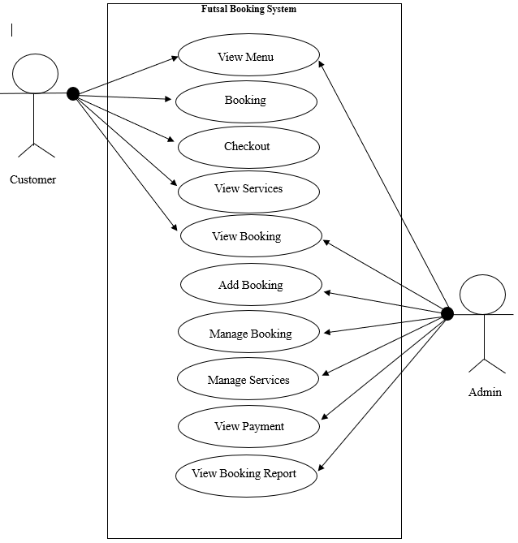
Logout
Login
Figure 2.1: Use case Diagram (Draw.io, 2024)

Table 2.1: Description of the Use-case Diagram
Actors | Customer, admin
Description | A customer can book futsal, view about futsal while the admin can see those pending bookings in
Data | User’s information, Admin’s information
Stimulus | Clients
Response | Confirmation that database has been updated. Then bookings list is shown to the admin.
Comment | The user must input correct data while creating bookings.

2.5.2 ER-Diagram
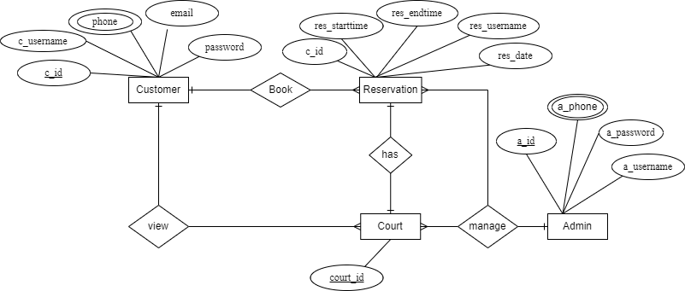
This ERD is created using ER-modeling itself. ER-modeling is a data modeling method. ERD, used in this software engineering, has helped to produce a conceptual data model of this system. The ERD is used to connect the logical structure of the database to users. In particular, the ERD effectively communicates the logic of the database to users. ERD of this system is represented below. (Draw.io, 2024)
Figure 2.2 ER-Diagram (Draw.io, 2024)

In this ER diagram, we have several entities:
- Customers: It represents the user of the system who can book futsal. It includes attributes such as c_id, name, email, phone, and password.
- Reservation: It represents the bookings made by users. It includes attributes such as c_id (to associate with the user who booked it), res_date, starttime, endtime and other relevant details as shown in figure.
- Admin: It represents the administrative users who manage the system. It includes attributes such as a_id, username, password, and other relevant details as shown in figure.

The relationships between the entities are represented using lines connecting them. Here’s a summary of the relationships:
- Users have a one-to-many relationship with reservations, as a user can have multiple reservations, but each reservation belongs to only one user.

2.5.3 Activity Diagram
Activity Diagram is another important behavioral diagram in UML diagram to describe dynamic aspects of the system. Activity diagram is essentially an advanced version of flow chart that modeling the flow from one to another activity. (Draw.io, 2024)
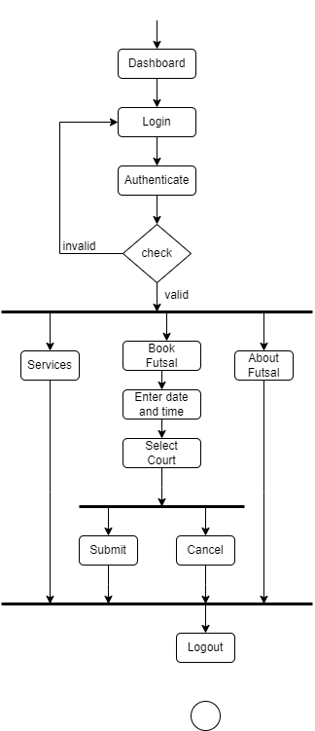
Figure 2.3: Client-side Activity Diagram (Draw.io, 2024)

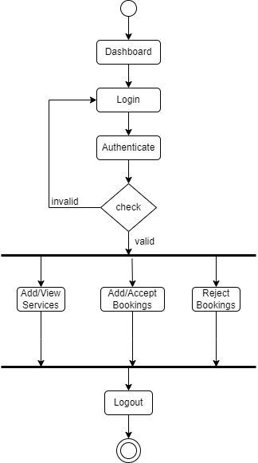

Figure 2.4: Admin-side Activity Diagram (Draw.io, 2024)

2.5.4 Sequence Diagram
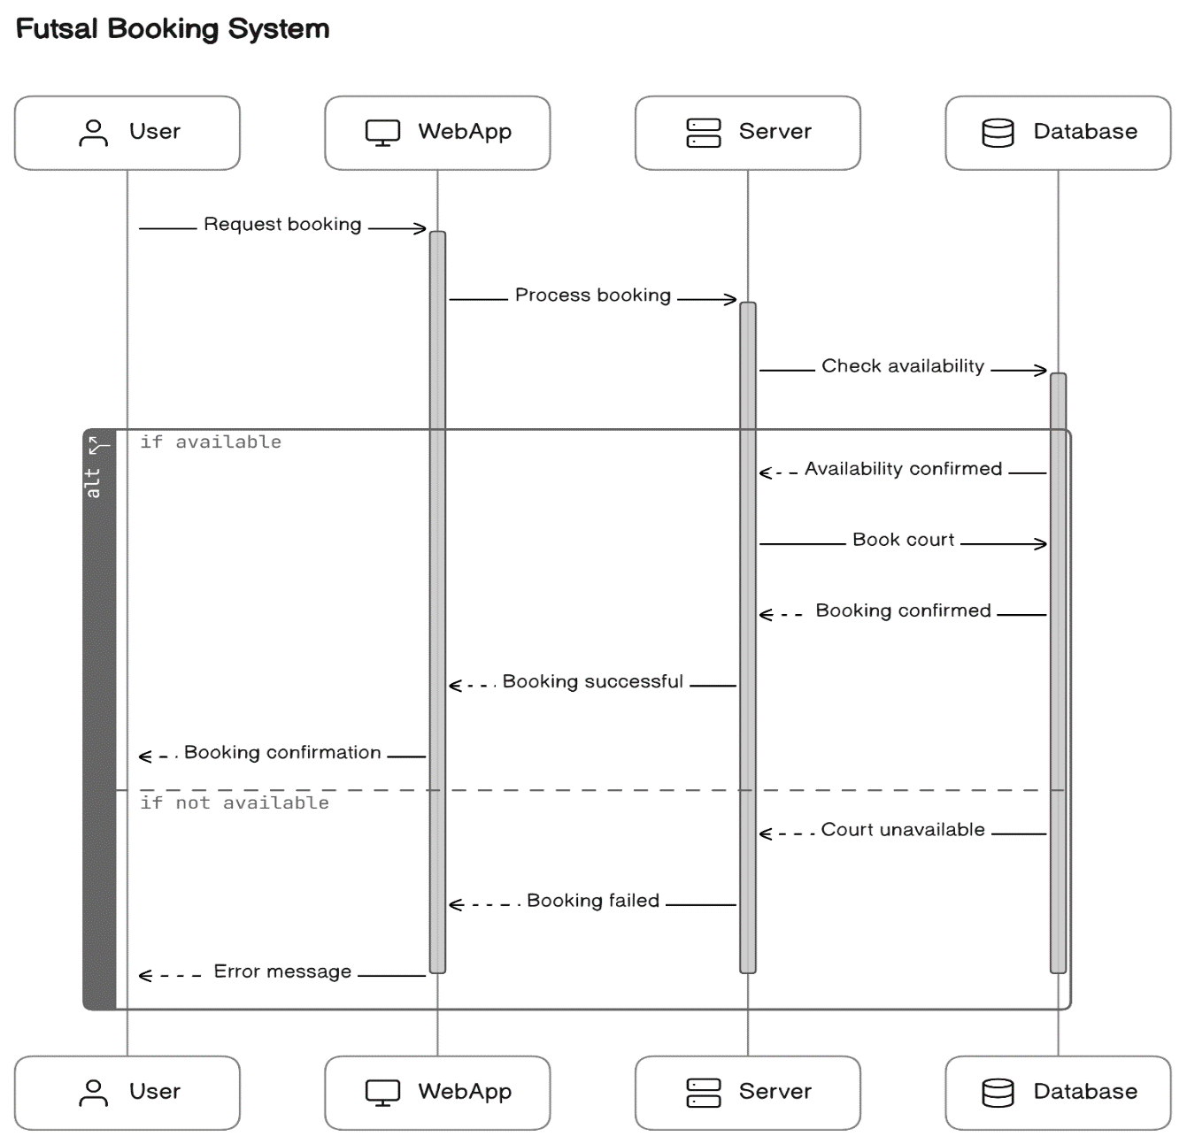
UML Sequence Diagrams are integration diagrams that detail how operations are carried out. They capture the integration between objects in the contest of a collaboration. Sequence diagrams are time focus and they show the order of the interaction visually by using the vertical axis of the diagram to represent time what message are sent and when.
Figure 2.5: Sequence Diagram (DiagramGpt, 2024)

2.6 System Testing
System testing is a type of software testing that evaluates the overall functionality and performance of a complete and fully integrated software solution. It tests if the system meets the specified requirements and if it is suitable for delivery to the end-users. This type of testing is performed after the integrations testing and before the acceptance testing. After each section of the application was completed, it was tested so that errors could be corrected.

2.6.1 Unit Testing
Unit testing was undertaken during the actual implementation of the system. Each time some code was written it was run and monitored for the bug. As bugs were discovered they were corrected by adding code or modifying the existing code. Several bugs were corrected by analyzing the error messages and correcting them by chaining in code. After development of the system has been completed testing was also performed. Functionality testing and interface testing combined to ensure the system functionality as requirement.

2.6.2 Test case
A test case is a set of actions performed on a system to determine if it satisfies software requirements and functions correctly.
The testing process and results of the login page has been shown in the table below:
Table 2.2: Test-Case
Test Case | Test Scenario | Test Data | Expected Result | Status
1 | Check response when invalid username and password is entered. | Username=users  Password=password | Message Display “Either username or password is incorrect” | Pass
2 | Check response with blank username and blank password is submitted | Username=  Password= | Message display “Either username or password is incorrect” | Pass
3 | Check response when correct username and incorrect password is entered | Username=abs  Password=pass123 | Message Display “Either username or password is incorrect” | Pass
4 | Check response when incorrect username and correct password is entered | Username=abs  Password=pass | Message Display “Either username or password is incorrect” | Pass
5 | Check response when valid username and password is entered | Username=user  Password=pass | Redirect to User Dashboard  Panel | Pass

2.6.3 Validation Testing
In this requirement established as part of software requirements analysis are validated against the software that has been constructed. Validation testing provides final assurance that software meets all functional, behavioral and performance requirements. Validation can be defined in many ways, but a simple definition is that validation succeeds when software functions in a manner which it intends to achieve.

2.7 Findings
The findings of this study initially involved the identification and analysis of existing problems. Subsequently, potential solutions were assessed, and several concepts were implemented. The software was conceptualized and developed as a response to the identified issues. The findings encapsulate the delineation of problems, proposed solutions, and the methodology employed to translate conceptual solutions into tangible system features within the developed software. The findings for this project can be subdivided into followings categories:
- Requirement Analysis Findings: In addition to all the requirements, such as the ability to record customer details and track bookings, the organization is expected to add more features, like attaching invoices.
- Design: The system follows a simple and user-friendly design.

CHAPTER III DISCUSSION AND CONCLUSION

3.1 Discussion
Online Booking Software is designed to facilitate online bookings and reservation for customers as well as staff and agents. It goes without saying that such an important process requires reliability and efficiency which good online booking software can provide.
Currently, Star Futsal has been managing the bookings manually i.e. by recording it in the books. The transactions are recorded manually in books. To eradicate the problems prevailing in the organizations, this software is developed. This is a web-based application.
Using this software, organizations can obtain following benefits:
- Digitally book Futsal as per convenience.
- Can view the transaction history easily, at any time.

3.2. Conclusion
The Futsal Booking Website project for “Star Futsal” has been successfully developed and completed within the stipulated timeframe, meeting the defined objectives. Upon evaluation, the system is poised to offer users a comprehensive online court booking experience. The adoption of a development model facilitated continuous checks and improvements throughout each phase of coding. This summer project has provided invaluable practical insights into the workings of an online booking system platform, enriching my understanding of online business operations. The experience has been enlightening, and I have endeavored to ensure the project's clarity, simplicity, and effectiveness. In summary, this project has significantly contributed to skill enhancement and learning opportunities, culminating in successful implementation.

REFERENCES
DiagramGpt. (2024). Diagrams. Sequence diagram. Retrieved from https://www.eraser.io/diagramgpt
Draw.io. (2024). Diagrams. Activity Diagram, Use-case Diagram, ER-Diagram. Retrieved from https://app.diagrams.net/
geeksforgeeks. (2024). Prototyping Model – Software Engineering. Prototyping Model – Software Engineering. Retrieved from https://www.geeksforgeeks.org/software-engineering-prototyping-model/
Hughes, J. (2023). Why Functional Programming Matters. Computer Journal, 32(2). Retrieved 2 12, 2024, from http://www.cse.chalmers.se/~rjmh/Papers/whyfp.html
StackoOverflow. (2024). What is feasibility study. Feasibility study. Retrieved from https://stackoverflow.com/questions/tagged/feasibility

APPENDICES
Some Questions asked during the interview are listed below:
- What are the opening hours of the futsal?
- Have you ever used an online reservations system for booking a futsal court before?
- How many days in advance do you typically book a futsal court?
- Have you ever experienced issues with double booking or canceled bookings?
- What is the busiest day of the week?
- What are the hours when the highest number of bookings are sought?
- What payments methods are currently accepted in futsal?
- What are the offers that you would give to the regular customers?

Dear Respondent,
The following questionnaire is for my Summer Project titles “Futsal Booking System with references to Star Futsal”. This information I provide is for educational provision only Thank you for your cooperation and the valuable time.

SCREENSHOTS
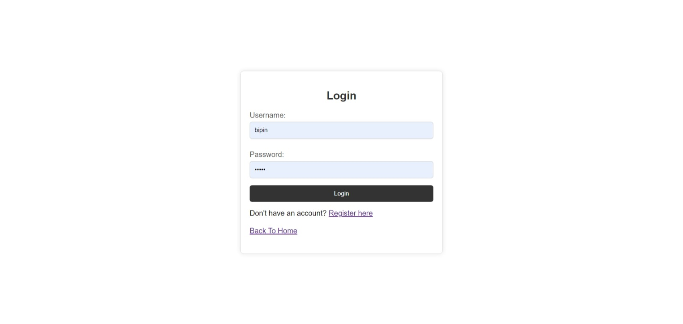
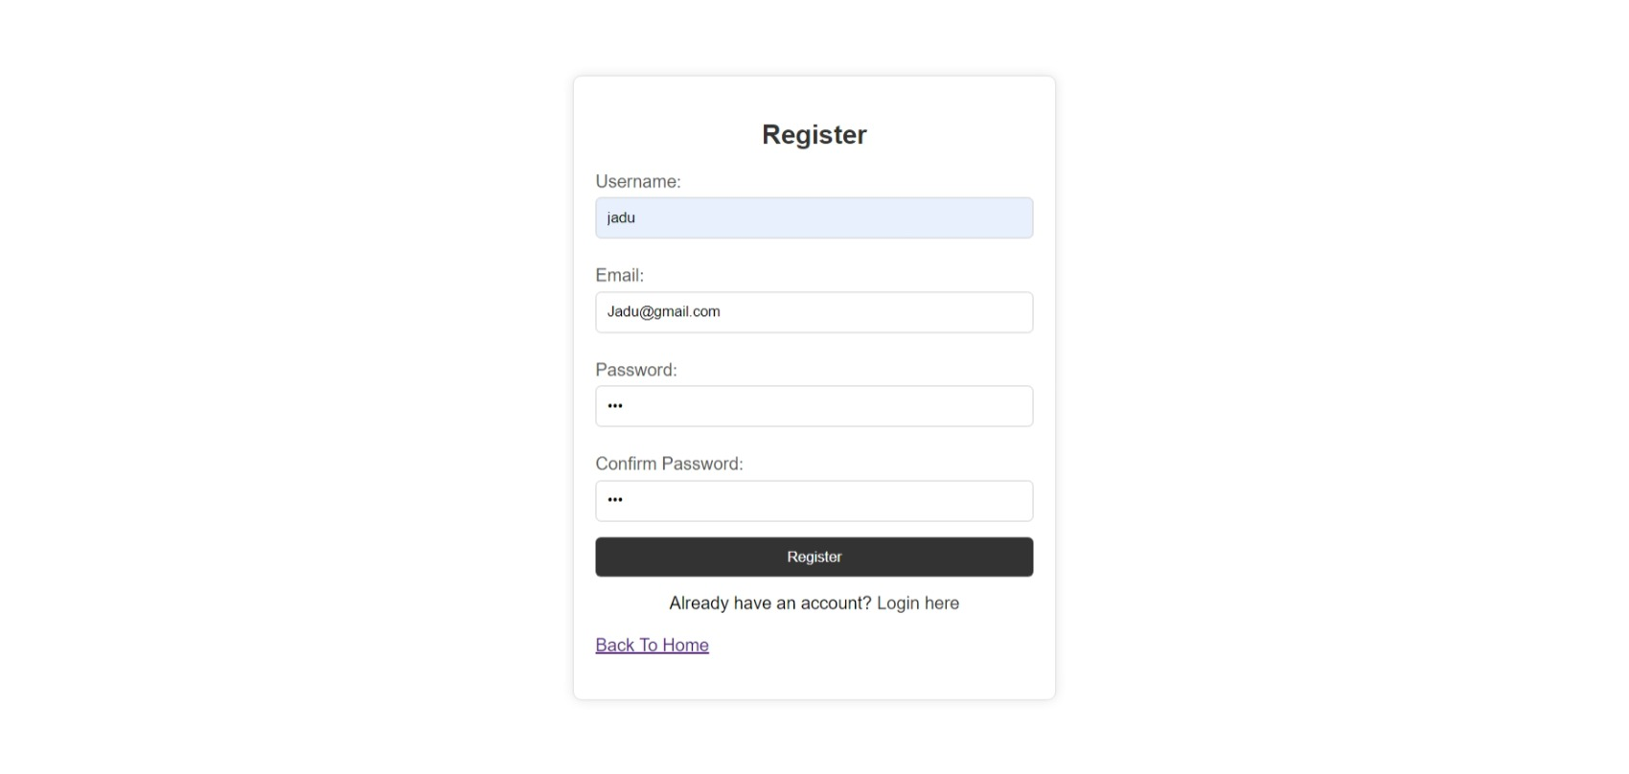
Login & Registration Form

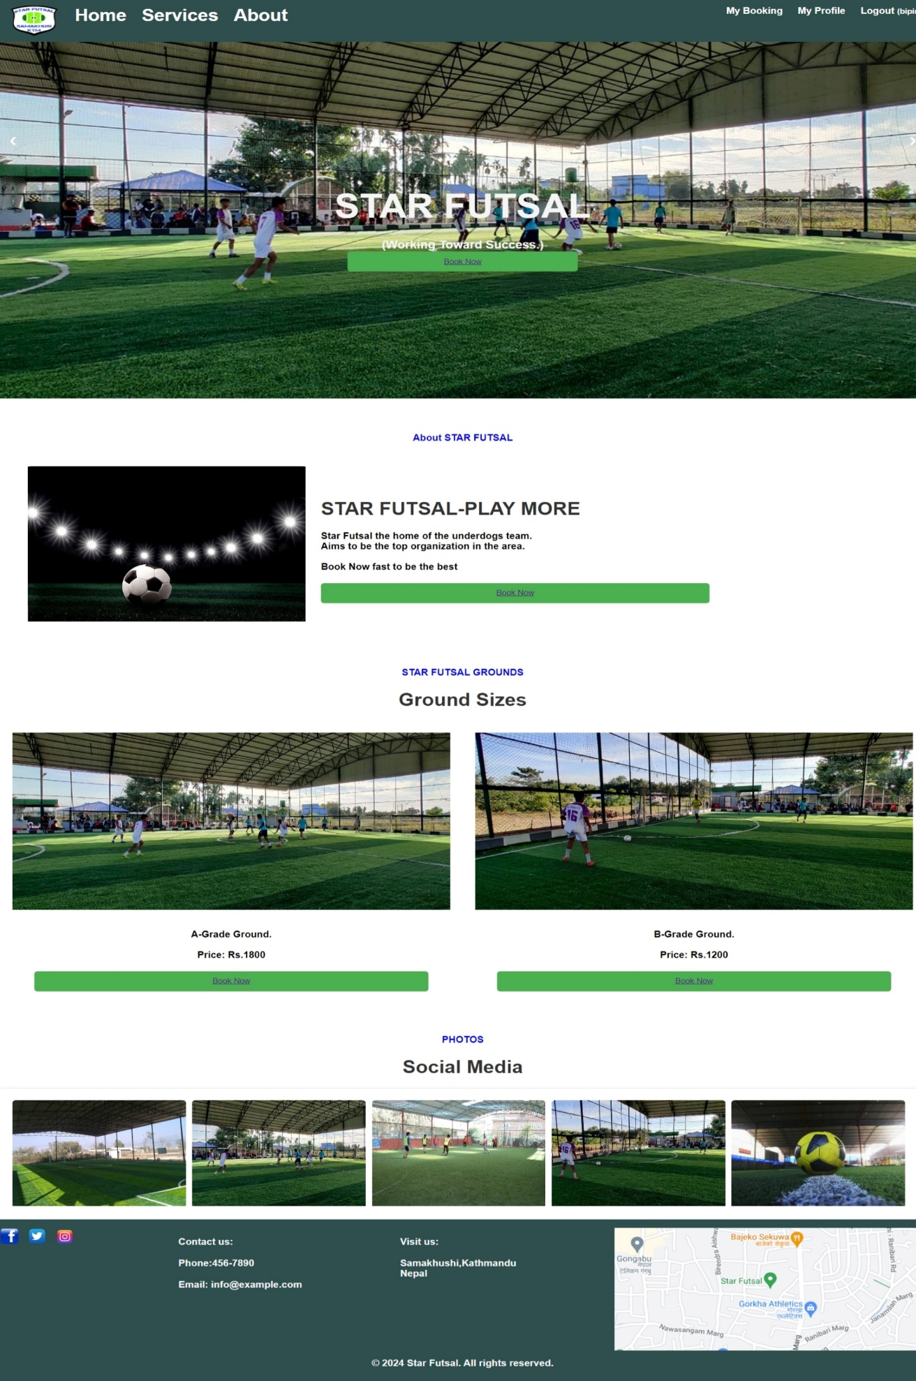
Client-side Panel (Screenshots)

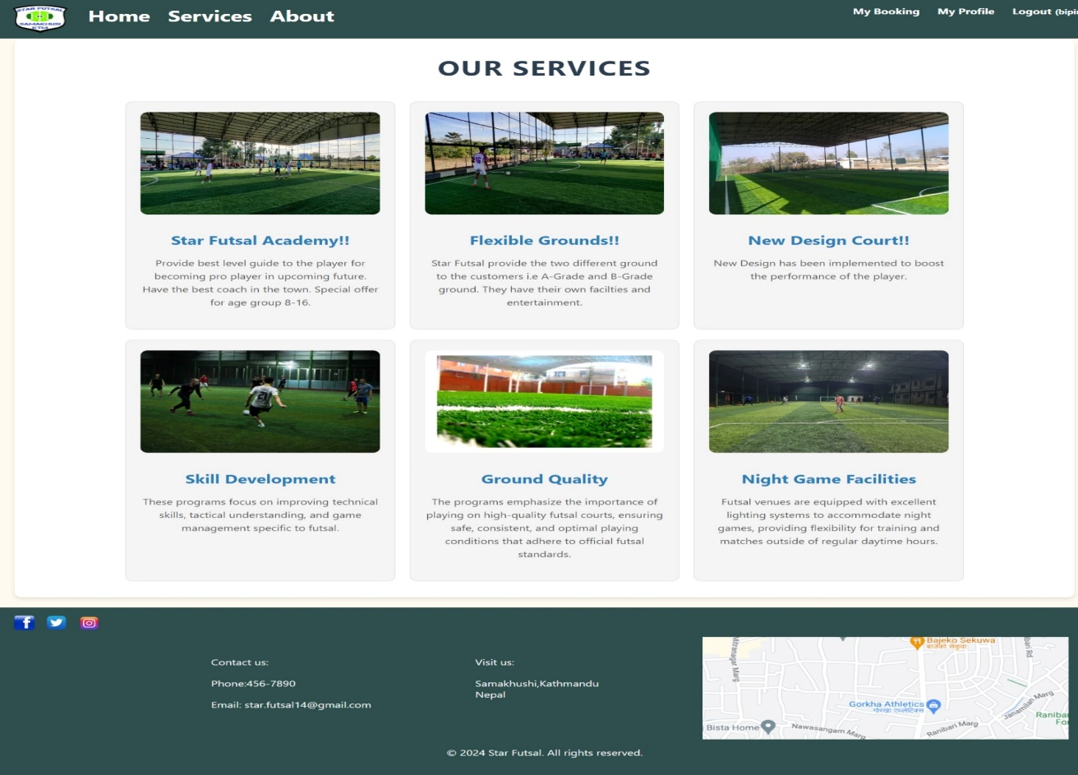
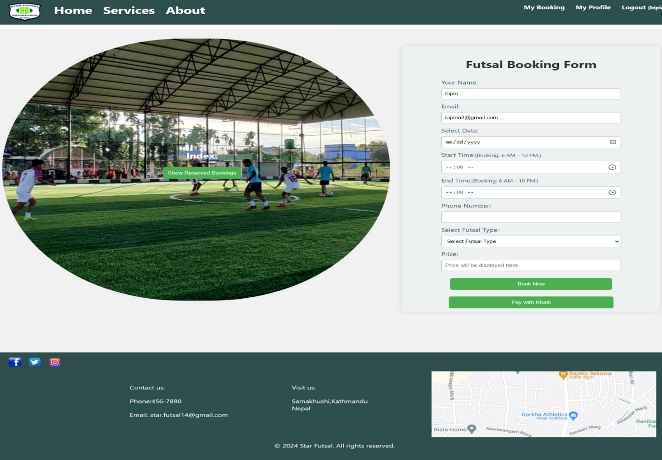

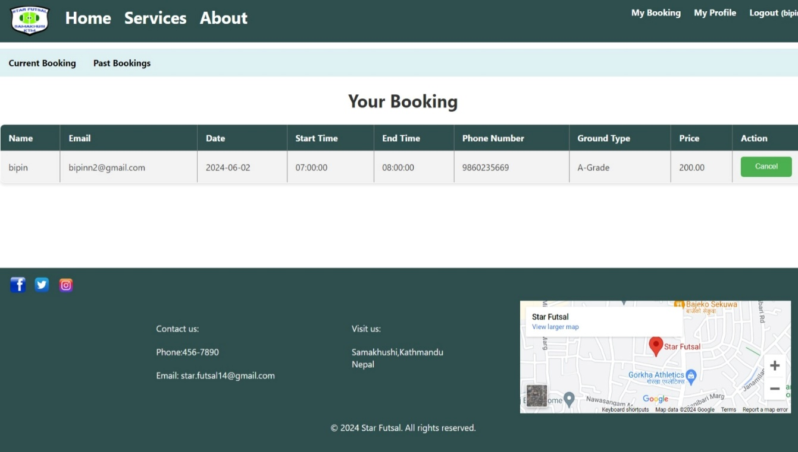

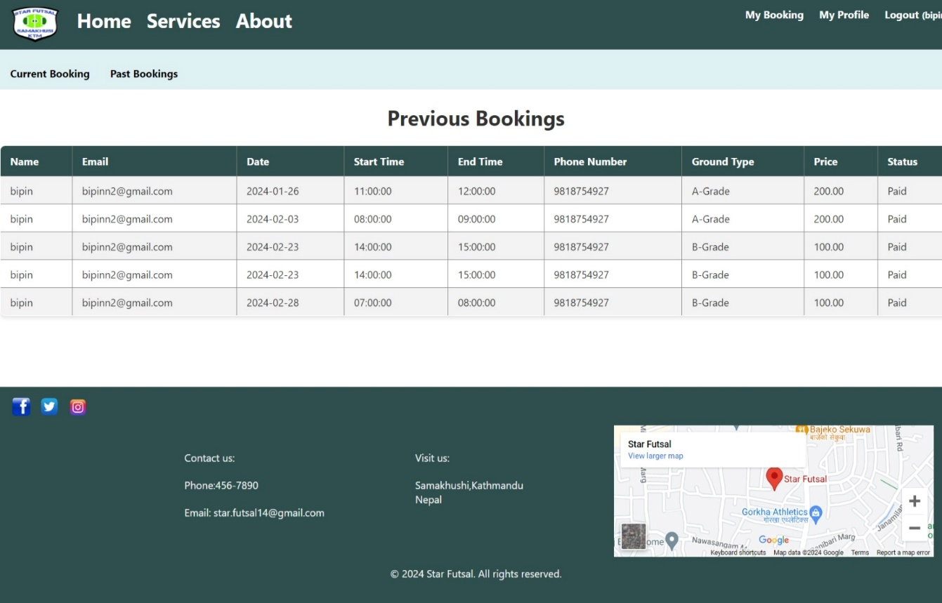

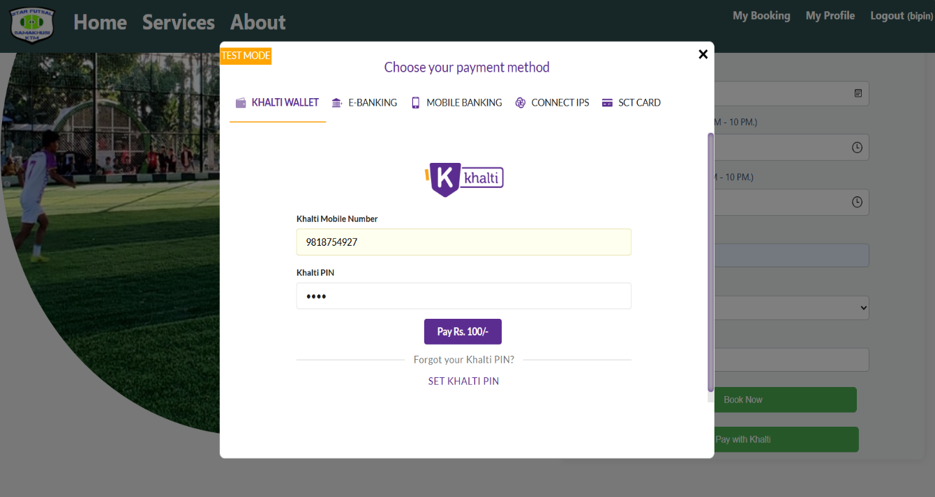

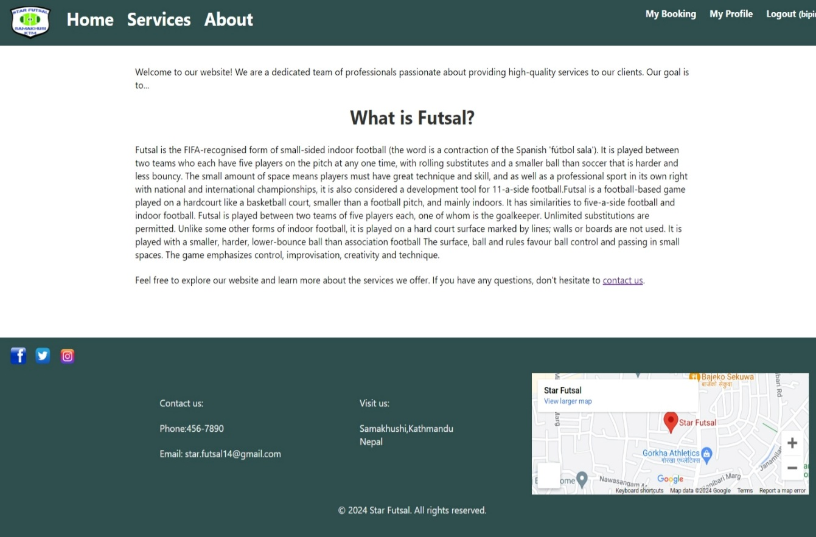
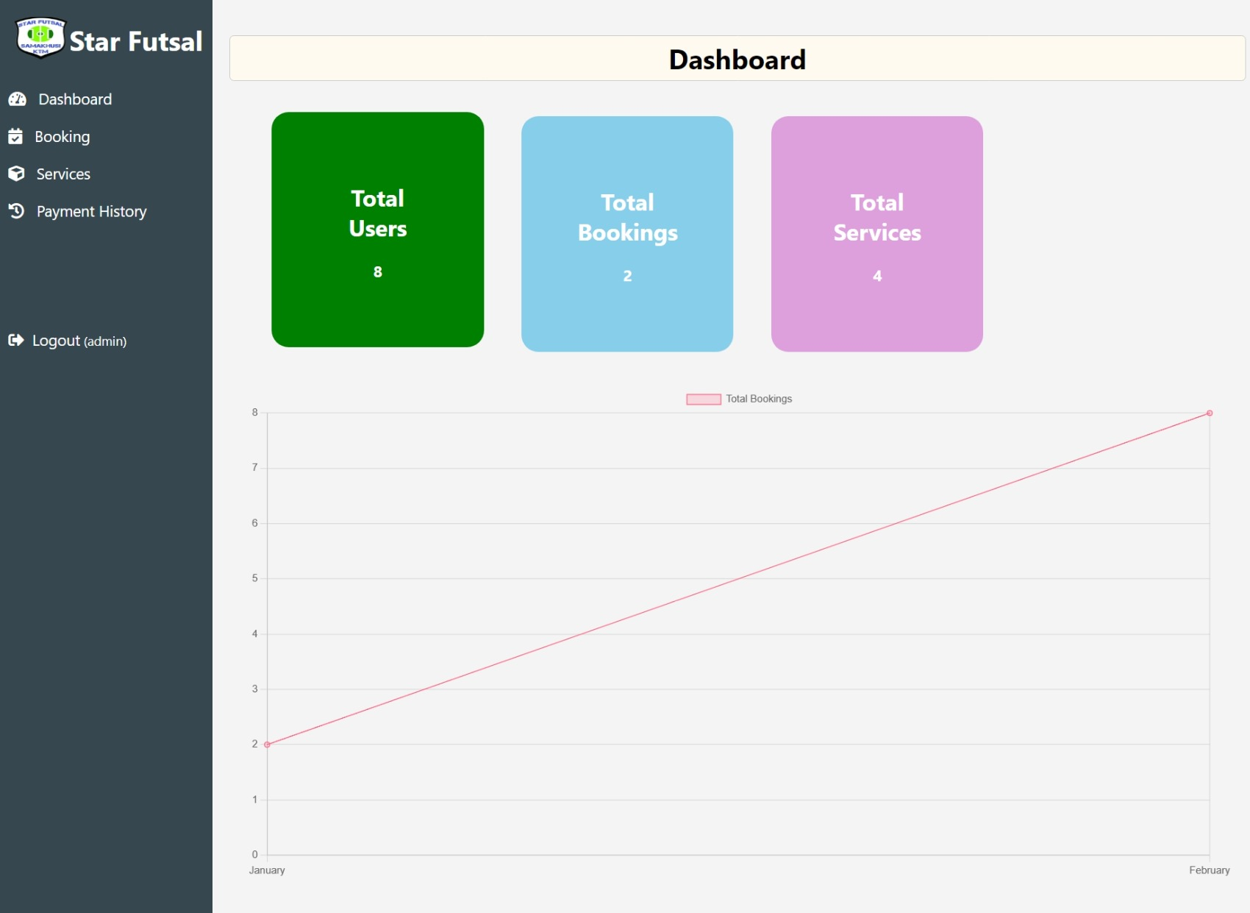
Admin-side Panel(Screenshots)

